

.INDEX.
S.L. | Name of The Problem
01 | Plot the following signal operations using user defined function -  a. adding ,b. multiplication, c. Scaling, d. shifting and e. folding.
02 | Plot the following transformation x1(n) = 2x(n-5) - 3x(n+4).
03 | Explain and Implementation the unit Impulse sequence, the unit Step sequence, the unit Ramp sequence.
04 | Explain and Implement convolution of signal.
05 | Explain and Implement correlation of signal.
06 | Extract relevant features such as filtering, feature extraction, pick detection, heart rate etc. from PPG signal.
07 | Explain and Implement Discrete Fourier Transform (DFT) using python.
08 | Explain and Implement Frequency bin using python.

Problem No: 01

Problem Name: Plot following signal operations using user defined function – a. adding, b. multiplication, c. Scaling, d. shifting and e. folding.

Objective:
To implement and visualize basic signal operations (addition, multiplication, scaling, shifting, and folding) using user-defined functions in Python.

Theory:
Signal processing involves various operations to manipulate signals for analysis and transformation. The fundamental operations are:
- Addition of Two Signals:
When two discrete-time signals x1[n] and x2[n] are added, the result is given by:
y[n]= x1​[n]+x2​[n]
This operation combines the amplitudes of both signals at corresponding time indices.
- Multiplication of Two Signals:
Element-wise multiplication of two signals is given by:
y(t) = x1(t) * x2(t)
This operation is used in modulation and filtering.
- Scaling of a Signal:
A signal x[n] is scaled by a factor α as follows:
y[n]=α⋅x[n]
This amplifies or attenuates the signal’s amplitude.
- Shifting of a Signal:
A signal is delayed or advanced by shifting its index by k:
  - Right shift (delay):
y[n]=x[n−k]
  - Left shift (advance):
y[n]=x[n+k]
- Folding (Time Reversal) of a Signal:
Folding reflects the signal around the vertical axis:
y[n]=x[−n]
This is useful in symmetry analysis and convolution.

Source Code:
import numpy as np
import matplotlib.pyplot as plt

def signal_add(x1,x2):
return x1+x2
def signal_mul(x1,x2):
return x1*x2
def signal_scaling(x,alpha):
return alpha*x
def signal_shifting(n,shift):
return n+shift
def signal_folding(x):
return np.flip(x)

t = np.arange(-10,10,0.01)
x1 = np.array([1,2,3,4,5])
x2 = np.array([5,4,3,2,1])
n = np.array([-2,-1,0,1,2])

p1 = np.sin(2 * np.pi * 1 * t)
p2 = np.cos(2 * np.pi * 0.5 * t)

added_signal = signal_add(x1,x2)
multiplied_signal = signal_mul(x1,x2)
scaled_signal = signal_scaling(x1,2)
shifted_signal1 = signal_shifting(n,2)
shifted_signal2 = signal_shifting(n,-2)
folded_signal = signal_folding(x1)

plt.figure(figsize=(16,20))

plt.subplot(4,2,1)
plt.stem(n,x1)
plt.xlabel("time")
plt.ylabel('amplitude')
plt.title('Original signal x1')
plt.grid()

plt.subplot(4,2,2)
plt.stem(n,x2)
plt.xlabel("time")
plt.ylabel('amplitude')
plt.title('Original signal x2')
plt.grid()

plt.subplot(4,2,3)
plt.stem(n,added_signal)
plt.xlabel("time")
plt.ylabel('amplitude')
plt.title('Signal addition')
plt.grid()

plt.subplot(4,2,4)
plt.stem(n,multiplied_signal)
plt.xlabel("time")
plt.ylabel('amplitude')
plt.title('multiplied_signal')
plt.grid()

plt.subplot(4,2,5)
plt.stem(n,scaled_signal)
plt.xlabel("time")
plt.ylabel('amplitude')
plt.title('Original signal (x1*2)')
plt.grid()

plt.subplot(4,2,6)
plt.stem(shifted_signal1,x1)
plt.xlabel("time")
plt.ylabel('amplitude')
plt.title('2 shifted signal')
plt.grid()

plt.subplot(4,2,7)
plt.stem(shifted_signal2,x1)
plt.xlabel("time")
plt.ylabel('amplitude')
plt.title('-2 shifted signal')
plt.grid()

plt.subplot(4,2,8)
plt.stem(n,folded_signal)
plt.xlabel("time")
plt.ylabel('amplitude')
plt.title('Folded signal(x1)')
plt.grid()

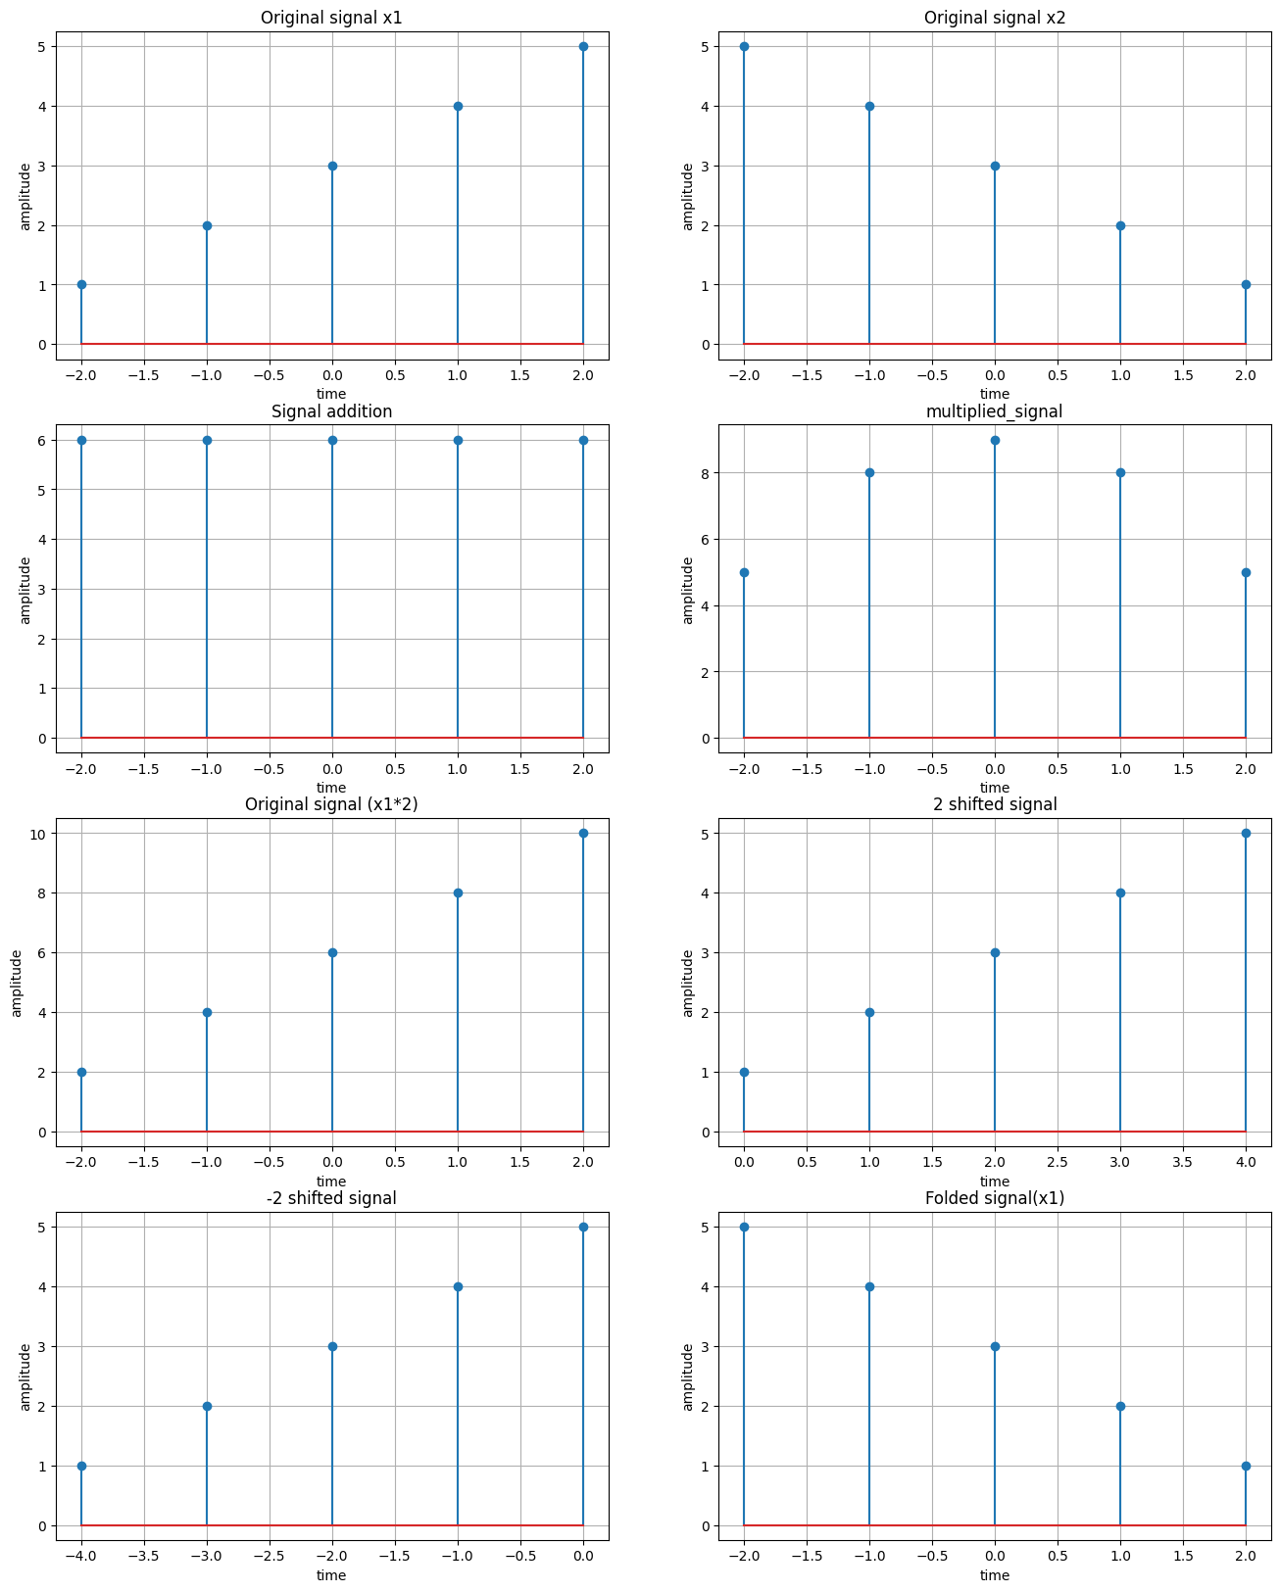
Sample Input & Output:

Problem No: 02

Problem Name: Plot the following transformation x1(n) = 2x(n-5) - 3x(n+4)

Objective:
To plot the transformed signal x1(n) = 2x(n − 5) − 3x(n + 4) and visualize its effect on the original signal x(n).

Theory:
A discrete-time signal x(n)x(n)x(n) can be modified using operations such as scaling, shifting, and multiplication.
The given transformation:
x1(n)=2x(n−5)−3x(n+4)
- Time Shifting:
  - x(n−5) shifts the signal right by 5 units (delayed).
  - x(n+4) shifts the signal left by 4 units (advanced).
- Scaling:
  - The signal x(n−5) is multiplied by 2.
  - The signal x(n+4) is multiplied by -3.
- Addition/Subtraction:
  - The final signal is obtained by adding the two scaled versions.

Source Code:
import numpy as np
import matplotlib.pyplot as plt

# Define the original signal x(n) (e.g., unit impulse or step function)
n = np.arange(-10, 10, 1) # Discrete time range
x_n = np.zeros_like(n) # Start with a zero array

# For simplicity, we will define x(n) as a unit impulse at n=0
x_n[n == 0] = 1 # Unit impulse at n=0

# Apply the transformation x1(n) = 2x(n-5) - 3x(n+4)
x1_n = 2 * np.roll(x_n, 5) - 3 * np.roll(x_n, -4)

# Plot the original signal and the transformed signal
plt.subplot(2, 1, 1)
plt.stem(n, x_n)
plt.title("Original Signal x(n)")

Text(0.5, 1.0, 'Original Signal x(n)')

plt.subplot(2, 1, 2)
plt.stem(n, x1_n)
plt.title("Transformed Signal x1(n) = 2x(n-5) - 3x(n+4)")

plt.tight_layout()
plt.show()

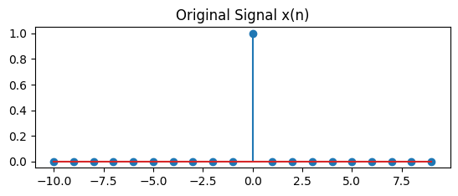
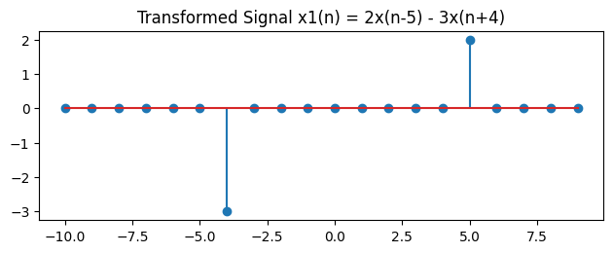
Sample Input & Output:

Problem No: 03

Problem Name: Explain and Implementation the unit Impulse sequence, the unit Step sequence, the unit Ramp sequence.

Objective:
To generate and understand three fundamental signals: unit impulse, unit step, and unit ramp.

Theory:
In signal processing and discrete-time systems, the Unit Impulse Sequence, Unit Step Sequence, and Unit Ramp Sequence are fundamental discrete-time signals used for analysis and system characterization.

Source Code:
import numpy as np
import matplotlib.pyplot as plt

# Generate a discrete-time index
n = np.arange(-10, 11) # Range from -10 to 10

# Generate a random signal
random_signal = np.random.uniform(-1, 1, len(n)) # Random values between -1 and 1

# Step Sequence (u[n])
step_sequence = np.heaviside(n, 1) # 1 for n >= 0, 0 for n < 0

# Impulse Sequence (δ[n])
impulse_sequence = np.zeros_like(n) # All zeros
impulse_sequence[n == 0] = 1 # 1 at n = 0

# Ramp Sequence (r[n])
ramp_sequence = np.where(n >= 0, n, 0) # n for n >= 0, else 0

# Plot the signals
plt.figure(figsize=(10, 8))

# Plot Random Signal
plt.subplot(4, 1, 1)
plt.stem(n, random_signal)
plt.title("Random Signal")
plt.xlabel("n")
plt.ylabel("Amplitude")

# Plot Step Sequence
plt.subplot(4, 1, 2)
plt.stem(n, step_sequence)
plt.title("Step Sequence u[n]")
plt.xlabel("n")
plt.ylabel("Amplitude")

# Plot Impulse Sequence
plt.subplot(4, 1, 3)
plt.stem(n, impulse_sequence)
plt.title("Impulse Sequence δ[n]")
plt.xlabel("n")
plt.ylabel("Amplitude")

# Plot Ramp Sequence
plt.subplot(4, 1, 4)
plt.stem(n, ramp_sequence)
plt.title("Ramp Sequence r[n]")
plt.xlabel("n")
plt.ylabel("Amplitude")

plt.tight_layout()
plt.show()

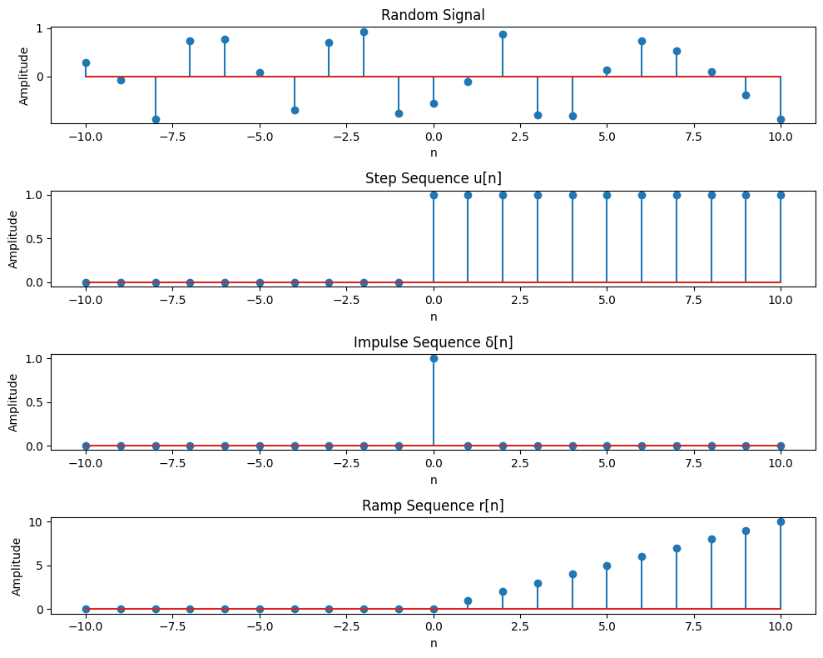
Sample Input & Output:

Problem No: 04

Problem Name: Explain and Implement convolution of signal.

Objective:
To compute and visualize the convolution of two discrete-time signals, demonstrating how the output signal is formed by combining the input signal and the system's impulse response.

Theory:
Convolution is a mathematical operation that combines two signals to form a third signal. It describes the output of a linear time-invariant (LTI) system when the input signal is passed through the system's impulse response.
Mathematically, discrete-time convolution is given by:
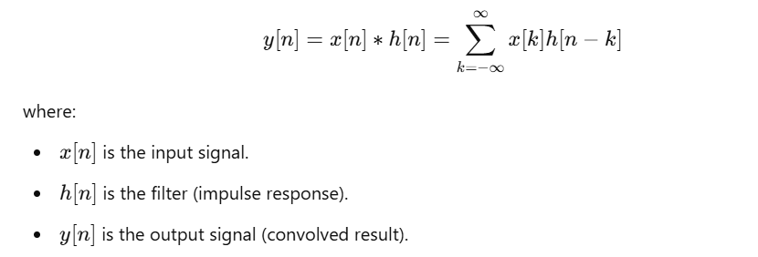

Source Code:
import numpy as np
import matplotlib.pyplot as plt

# Generate two random signals
np.random.seed(42) # Ensures reproducibility
x = np.random.randint(0, 10, 10) # First random signal (length 10)
h = np.random.randint(0, 10, 5) # Second random signal (length 5)

# Compute convolution (It combines two signals to produce a third signal)
y = np.convolve(x, h, mode='full') # mode='full' returns the complete convolution result of length (N+M-1).

# Normalize convolution result
y_norm = y / np.max(np.abs(y)) # Normalize by maximum absolute value

# Define time indices
n_x = np.arange(len(x)) # Time indices for x
n_h = np.arange(len(h)) # Time indices for h
n_y = np.arange(len(y)) # Time indices for y

# Plot original signals and convolution result
plt.figure(figsize=(10, 6))

# Plot x[n]
plt.subplot(3, 1, 1)
plt.stem(n_x, x, linefmt='b-', markerfmt='bo', basefmt='k')
plt.title("Input Signal x[n]")
plt.xlabel("n")
plt.ylabel("Amplitude")
plt.grid()

# Plot h[n]
plt.subplot(3, 1, 2)
plt.stem(n_h, h, linefmt='r-', markerfmt='ro', basefmt='k')
plt.title("Filter/Impulse Response h[n]")
plt.xlabel("n")
plt.ylabel("Amplitude")
plt.grid()

# Plot normalized convolution result y[n]
plt.subplot(3, 1, 3)
plt.stem(n_y, y_norm, linefmt='g-', markerfmt='go', basefmt='k')
plt.title("Normalized Convolution Result y[n] = x[n] * h[n]")
plt.xlabel("n")
plt.ylabel("Normalized Amplitude")
plt.grid()

plt.tight_layout()
plt.show()
# Print values
print("Input Signal x[n]:", x)
print("Filter h[n]:", h)
print("Convolution Output y[n]:", y)
print("Normalized Convolution Output y[n]:", y_norm)

Sample Input & Output:
Input Signal x[n]: [6 3 7 4 6 9 2 6 7 4]
Filter h[n]: [3 7 7 2 5]
Convolution Output y[n]: [ 18 51 84 94 131 126 154 127 125 152 99 72 43 20]
Normalized Convolution Output y[n]: [0.11688312 0.33116883 0.54545455 0.61038961 0.85064935 0.81818182
1. 0.82467532 0.81168831 0.98701299 0.64285714 0.46753247
0.27922078 0.12987013]
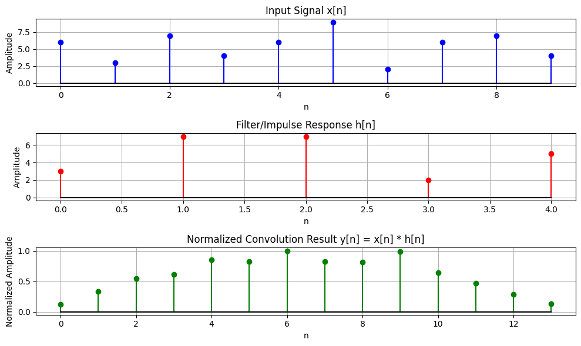

Problem No: 05

Problem Name: Explain and Implement Correlation of signal.

Objective:
To compute and visualize the correlation of signals, including both auto-correlation (a signal with itself) and cross-correlation (between two signals), to analyze their similarity and periodicity.

Theory:
1. Cross-Correlation:
Cross-correlation measures the similarity between two different signals as one is shifted relative to the other. It helps in detecting patterns and aligning signals. Mathematically, cross-correlation is defined as:

Applications of Cross-Correlation:
- Signal synchronization in communication systems.
- Template matching in image processing.
- Feature detection in machine learning.

2. Auto-Correlation:
Auto-correlation measures the similarity of a signal with itself over different shifts. It helps in identifying repetitive patterns within a signal. Mathematically, it is given by:
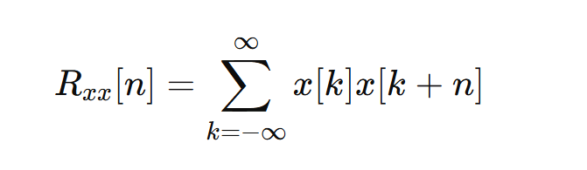
Applications of Auto-Correlation:
- Speech processing: Identifying periodicity in audio signals.
- Radar and sonar: Detecting objects by analyzing echo patterns.
- DNA sequencing: Finding repeated gene patterns.

Source Code:
import numpy as np
import matplotlib.pyplot as plt

# Create two signals
x = np.array([1, 2, 3, 4, 5]) # First signal
y = np.array([5, 4, 3, 2, 1]) # Second signal

# Compute Cross-Correlation (Cross-Correlation: Measures similarity between two different signals like x,y)
cross_corr = np.correlate(x, y, mode='full')

# Compute Auto-Correlation of x (Auto-Correlation: Measures similarity of a signal with itself )
auto_corr_x = np.correlate(x, x, mode='full')

# Compute Auto-Correlation of y
auto_corr_y = np.correlate(y, y, mode='full')

# Normalize Cross-Correlation
norm_factor = np.sqrt(np.correlate(x, x, mode='full')[len(x) - 1] * np.correlate(y, y, mode='full')[len(y) - 1])
cross_corr_norm = cross_corr / norm_factor

# Normalize Auto-Correlations
auto_corr_x_norm = auto_corr_x / auto_corr_x[len(x) - 1] # Divide by max value
auto_corr_y_norm = auto_corr_y / auto_corr_y[len(y) - 1] # Divide by max value

# Plot Cross-Correlation (Shows how x and y align at different shifts)
plt.figure(figsize=(10, 6))

plt.subplot(3, 1, 1)
plt.stem(range(-len(x) + 1, len(x)), cross_corr_norm)
plt.title("Normalized Cross-Correlation of x and y")
plt.xlabel("Lag")
plt.ylabel("Correlation (Normalized)")

# Plot Auto-Correlation of x
plt.subplot(3, 1, 2)
plt.stem(range(-len(x) + 1, len(x)), auto_corr_x_norm)
plt.title("Normalized Auto-Correlation of x")
plt.xlabel("Lag")
plt.ylabel("Correlation (Normalized)")

# Plot Auto-Correlation of y
plt.subplot(3, 1, 3)
plt.stem(range(-len(y) + 1, len(y)), auto_corr_y_norm)
plt.title("Normalized Auto-Correlation of y")
plt.xlabel("Lag")
plt.ylabel("Correlation (Normalized)")

plt.tight_layout()
plt.show()

# Print correlation values
print("Normalized Cross-Correlation:", cross_corr_norm)
print("Normalized Auto-Correlation of x:", auto_corr_x_norm)
print("Normalized Auto-Correlation of y:", auto_corr_y_norm)

Sample input & Output:
Normalized Cross-Correlation: [0.01818182 0.07272727 0.18181818 0.36363636 0.63636364 0.8
0.83636364 0.72727273 0.45454545]
Normalized Auto-Correlation of x: [0.09090909 0.25454545 0.47272727 0.72727273 1. 0.72727273
0.47272727 0.25454545 0.09090909]
Normalized Auto-Correlation of y: [0.09090909 0.25454545 0.47272727 0.72727273 1. 0.72727273
0.47272727 0.25454545 0.09090909]
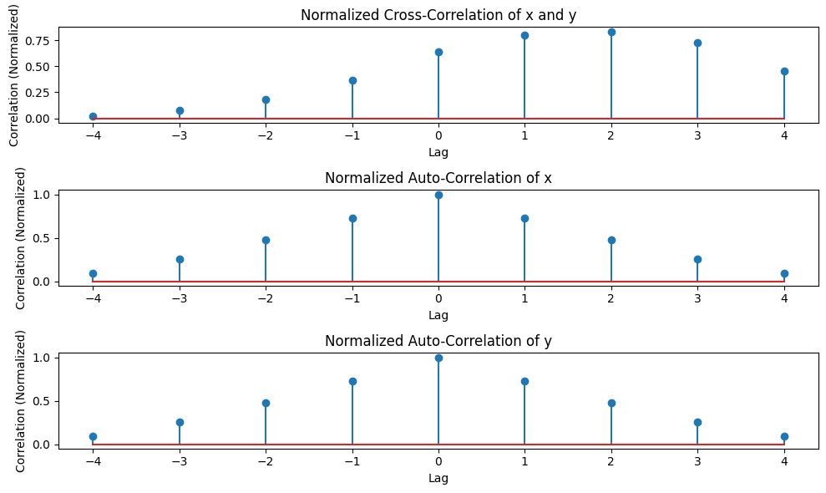

Problem No: 06

Problem Name: Extract relevant features such as filtering, feature extraction, pick detection, heart rate etc. from PPG signal.

Objective:
To extract relevant features such as filtering, peak detection, and heart rate calculation from a PPG (Photoplethysmogram) signal to analyze physiological parameters like heart rate and assess cardiovascular health.

Theory:
1. PPG Signal:
- The Photoplethysmogram (PPG) signal is an optical measurement of blood volume changes in tissue.
- It is used to monitor heart rate (HR), blood oxygen levels (SpO₂), and vascular conditions.
- The signal consists of a periodic waveform, reflecting heartbeats, and may contain noise and artifacts.
2. Signal Processing Steps:
- Signal Generation:
  - A synthetic PPG signal is created using sinusoidal functions with added noise.
  - Option to introduce abnormalities such as irregular peaks for arrhythmia simulation.
- Normalization:
  - The signal is normalized using Min-Max Scaling:
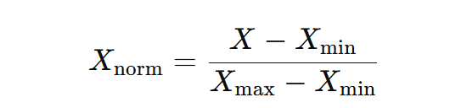
  - Ensures all values lie between 0 and 1.
- Bandpass Filtering (Noise Removal):
  - A Butterworth bandpass filter is used to retain relevant heart rate frequencies.
  - Removes low-frequency drift and high-frequency noise.
- Peak Detection:
  - Identifies heartbeats by detecting peaks in the filtered signal.
  - Uses scipy.signal.find_peaks() with parameters such as minimum distance between peaks and prominence.
- Feature Extraction:
  - R-R Intervals (time between consecutive heartbeats) are computed.
  - Heart Rate (HR) is estimated as:
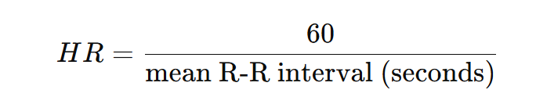
- Abnormality Detection:
  - Bradycardia: HR < 60 BPM (slow heart rate).
  - Tachycardia: HR > 100 BPM (fast heart rate).
  - Arrhythmia: Irregular heartbeat detected if R-R interval standard deviation is high.

Source Code:
import numpy as np
import matplotlib.pyplot as plt
from scipy.signal import find_peaks, butter, filtfilt

# Simulating a synthetic PPG signal (for demonstration)
fs = 1000 # Sampling frequency (Hz)
t = np.linspace(0, 10, fs * 10) # 10 seconds of data
ppg_signal = 0.5 * np.sin(2 * np.pi * 1.2 * t) + 0.3 * np.sin(2 * np.pi * 0.5 * t) + 0.1 * np.random.randn(len(t))

# Step 1: Bandpass Filtering (0.5-5 Hz)
def bandpass_filter(signal, lowcut, highcut, fs, order=4):
nyquist = 0.5 * fs
low = lowcut / nyquist
high = highcut / nyquist
b, a = butter(order, [low, high], btype='band')
filtered_signal = filtfilt(b, a, signal)
return filtered_signal

# Apply bandpass filter to PPG signal
lowcut = 0.5 # Low frequency (0.5 Hz)
highcut = 5.0 # High frequency (5 Hz)
filtered_ppg = bandpass_filter(ppg_signal, lowcut, highcut, fs)

# Step 2: Peak Detection
peaks, _ = find_peaks(filtered_ppg, distance=fs*0.6) # Minimum distance between peaks (0.6 seconds)

# Step 3: Heart Rate Calculation
peak_intervals = np.diff(peaks) / fs # Time between successive peaks (in seconds)
heart_rate = 60 / np.mean(peak_intervals) # Heart rate in beats per minute (bpm)

# Plot the results
plt.figure(figsize=(12, 6))

# Original PPG Signal
plt.subplot(3, 1, 1)
plt.plot(t, ppg_signal, label='Raw PPG Signal')
plt.title('Raw PPG Signal')
plt.xlabel('Time (seconds)')
plt.ylabel('Amplitude')
plt.grid()

# Filtered PPG Signal
plt.subplot(3, 1, 2)
plt.plot(t, filtered_ppg, label='Filtered PPG Signal', color='orange')
plt.scatter(t[peaks], filtered_ppg[peaks], color='red', label='Detected Peaks')
plt.title('Filtered PPG Signal with Detected Peaks')
plt.xlabel('Time (seconds)')
plt.ylabel('Amplitude')
plt.grid()

# Heart Rate Information
plt.subplot(3, 1, 3)
plt.text(0.5, 0.5, f'Heart Rate: {heart_rate:.2f} bpm', fontsize=14, ha='center')
plt.axis('off')
plt.title('Heart Rate Information')

plt.tight_layout()
plt.show()

print(f"Estimated Heart Rate: {heart_rate:.2f} bpm")

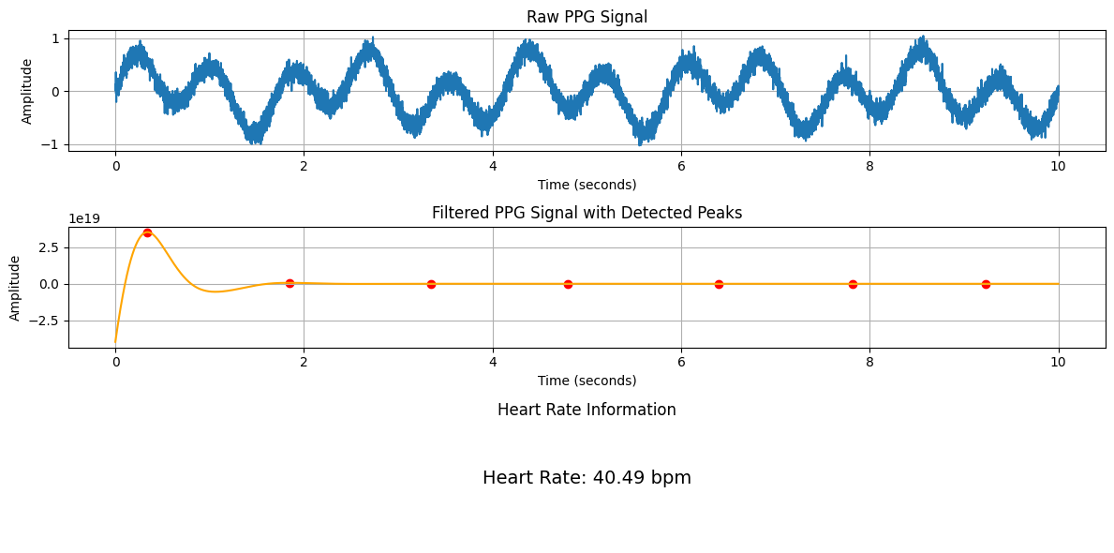
Sample Input & Output:

Problem No: 07

Problem Name: Explain and Implement Discrete Fourier Transform (DFT) using python.

Objective:
To explain and implement the Discrete Fourier Transform (DFT) using Python, and demonstrate how it can be used to analyze the frequency content of a discrete-time signal.

Theory:
1. Discrete Fourier Transform (DFT):
DFT transforms a time-domain signal into its frequency-domain representation. It is mathematically defined as:
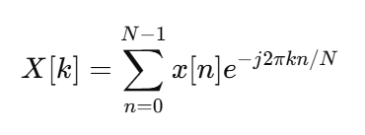
where:
- x[n] is the input signal.
- X[k] represents the frequency components of x[n].
- N is the total number of samples.
- k is the frequency index.

2. Inverse Discrete Fourier Transform (IDFT):
To recover the time-domain signal from its frequency representation, we use:
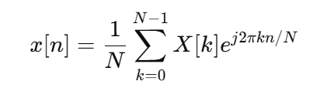
DFT is widely used for signal analysis, filtering, and frequency domain processing.

3. Implementation Details:
- The function DFT(x) computes the DFT from scratch using nested loops.
- A signal is generated with two frequency components (70 Hz and 90 Hz).
- The DFT is applied to analyze the frequency spectrum.
- The magnitude spectrum is plotted for interpretation.

Source Code:
import numpy as np
import matplotlib.pyplot as plt

# Step 1: Create a sample discrete signal (for example, a sum of two sinusoids)
fs = 1000 # Sampling frequency (Hz)
t = np.arange(0, 1, 1/fs) # Time vector for 1 second
f1 = 50 # Frequency of first sinusoid (Hz)
f2 = 120 # Frequency of second sinusoid (Hz)

# Create a signal that is the sum of two sinusoids
x = np.sin(2 * np.pi * f1 * t) + np.sin(2 * np.pi * f2 * t)

# Step 2: Compute the DFT of the signal manually using the DFT formula
N = len(x) # Length of the signal
X = np.zeros(N, dtype=complex) # Initialize the DFT array

# Calculate the DFT using the DFT formula
for k in range(N):
sum_val = 0
for n in range(N):
sum_val += x[n] * np.exp(-2j * np.pi * k * n / N)
X[k] = sum_val

# Step 3: Compute the frequency axis for plotting
frequencies = np.fft.fftfreq(N, 1/fs) # Frequencies corresponding to DFT bins

# Step 4: Plot the original signal and the magnitude of the DFT
plt.figure(figsize=(12, 6))

# Plot the original signal
plt.subplot(2, 1, 1)
plt.plot(t, x)
plt.title('Original Signal (Sum of Two Sinusoids)')
plt.xlabel('Time (seconds)')
plt.ylabel('Amplitude')
plt.grid()

# Plot the magnitude of the DFT (frequency domain representation)
plt.subplot(2, 1, 2)
plt.plot(frequencies[:N//2], np.abs(X)[:N//2]) # Plot only the positive frequencies
plt.title('Magnitude of DFT (Frequency Domain)')
plt.xlabel('Frequency (Hz)')
plt.ylabel('Magnitude')
plt.grid()

plt.tight_layout()
plt.show()

Sample Input & Output:
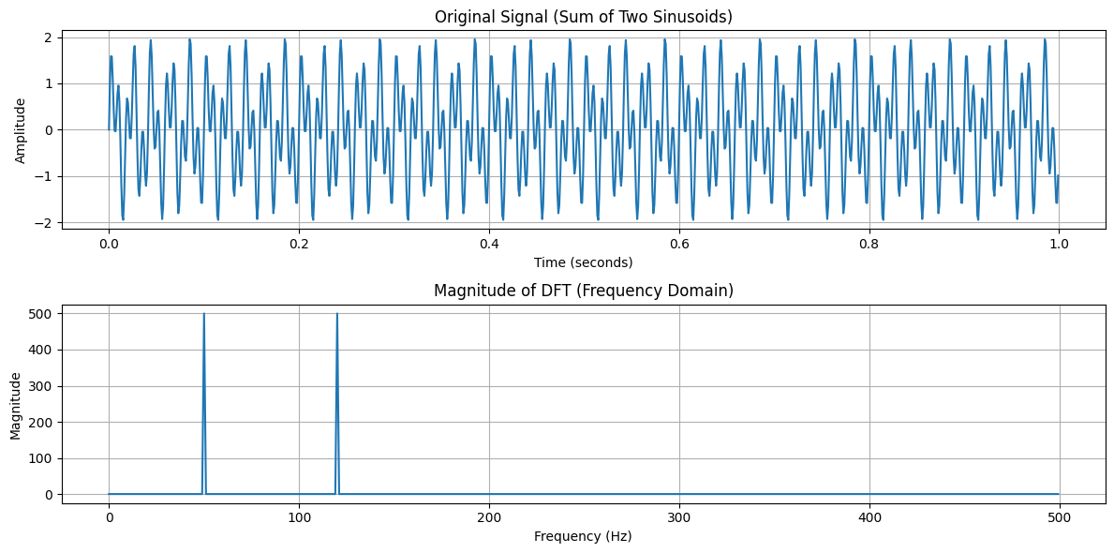

Problem No: 08

Problem Name: Explain and Implement Frequency bin using python.

Objective:
To understand and implement the Discrete Fourier Transform (DFT) and its frequency bins, and to analyze the frequency content of a discrete-time signal using Python.

Theory:
1. Fast Fourier Transform (FFT):
FFT is an efficient algorithm to compute the Discrete Fourier Transform (DFT). It converts a time-domain signal into the frequency domain using:
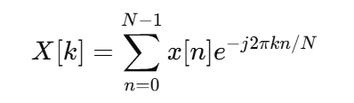
where:
- x[n] is the input signal.
- X[k] represents its frequency components.
- N is the number of samples.

2. Frequency Filtering in FFT Domain:
- High-frequency components above 500 Hz are removed by setting their magnitude to zero in the frequency spectrum.
- The cleaned signal is reconstructed using the Inverse FFT (IFFT):
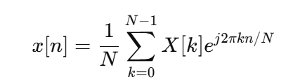

3. Generating a Noisy Signal:
- A pure sinusoidal wave at 440 Hz (A4 note in music) is created.
- Random noise is added to simulate real-world signal corruption.
- FFT filtering helps remove noise and restore the original signal.

Source Code:
import numpy as np
import matplotlib.pyplot as plt
from scipy.fft import fft, ifft, fftfreq

# Parameters
Fs = 1000 # Sampling frequency
T = 1 / Fs # Sampling interval
t = np.linspace(0, 1, Fs, endpoint=False) # Time vector

# Generate signals
pure_signal = np.sin(2 * np.pi * 440 * t) # 440 Hz sine wave
noisy_signal = pure_signal + np.random.normal(0, 0.5, t.shape) # Add noise

# Apply FFT and filter
fft_signal = fft(noisy_signal)
freqs = fftfreq(len(fft_signal), T)
fft_signal[np.abs(freqs) > 500] = 0 # Remove frequencies > 500 Hz
cleaned_signal = ifft(fft_signal).real # Inverse FFT to get cleaned signal

# Plotting
plt.figure(figsize=(12, 6))
plt.subplot(3, 1, 1)
plt.plot(t, pure_signal, 'k', label="Original Signal")
plt.subplot(3, 1, 2)
plt.plot(t, noisy_signal, 'r', label="Noisy Signal")
plt.subplot(3, 1, 3)
plt.plot(t, cleaned_signal, 'y', label="Cleaned Signal")
plt.tight_layout()
plt.show()

Sample Input & Output:
